
PRESENTED BY:
MUSAZA PATRICK 223019061
MANZI NSENGA IVAN 223004392
TRANSCONNECT

COMPUTING
INTELLIGENCE &
APPLICATIONS
UR-CST
CSE Year III
Academic year: 2025 – 2026
Module code & title: Computing Intelligence and Applications [CE80561]
Date: On Monday, December 09th, 2025

TransConnect AI-Driven Public Transportation Platform

Abstract
Public transport users in Rwanda, particularly on busy corridors such as Kabuga–Nyabugogo, often face unpredictable delays, inconsistent travel times, and a lack of real-time transit information, especially during peak hours. To address these challenges, this project introduces TransConnect—a smart, AI-powered web-based transit prediction platform designed to enhance commuter experience and operational efficiency.
The system employs machine learning and deep learning models—including Linear Regression, Random Forest, Gradient Boosting, Decision Trees, and Long Short-Term Memory (LSTM) networks—to predict accurate estimated times of arrival (ETAs). A comprehensive data preprocessing pipeline was developed to clean, integrate, and transform raw GPS and route data, which initially suffered from inconsistent naming conventions, mixed coordinate formats, and missing values. Key features such as inter-stop distances and travel time categories were engineered using the Haversine formula, and synthetic data augmentation was applied to simulate varying traffic conditions.
Among the models tested, the LSTM outperformed others, achieving the highest R² score of 0.982 and the lowest RMSE of 1.667, demonstrating its strength in learning sequential traffic patterns and time-dependent variations. The project highlights how structured data preprocessing and advanced AI modeling can transform public transportation systems by providing reliable, real-time predictions, reducing passenger uncertainty, and supporting data-driven urban mobility planning in Rwanda’s transition toward smart city infrastructure.

Keywords: AI transit prediction, machine learning, LSTM, public transport, ETA prediction, data preprocessing, Rwanda smart mobility.

1. Introduction
Public transportation serves as a vital component of urban mobility, particularly in growing cities. In Rwanda, commuters frequently face challenges related to unpredictable bus schedules, inconsistent travel durations, and a general lack of real-time transit information. These issues are especially pronounced during morning and evening rush hours, leading to increased waiting times, passenger frustration, and inefficient use of transport resources.
To address these operational and experiential gaps, this project proposes TransConnect—an intelligent, web-based transit prediction platform powered by artificial intelligence. Focusing on the high-demand Kabuga–Nyabugogo route in Kigali as a case study, the system leverages machine learning and deep learning techniques to deliver accurate Estimated Time of Arrival (ETA) predictions. By integrating real-time GPS data, historical travel patterns, and traffic-condition features, TransConnect aims to reduce commuter uncertainty, improve journey planning, and support data-informed transit management.
This report details the end-to-end development of TransConnect, from data collection and preprocessing to model evaluation and comparison. It highlights how AI-driven insights can enhance public transport reliability and align with Rwanda’s broader vision for smart, sustainable urban mobility.

Literature Review
The application of artificial intelligence and data-driven methods in public transportation has been extensively studied, with a focus on improving reliability, efficiency, and user satisfaction. This review synthesizes relevant research in the areas of transit prediction, data preprocessing, and machine learning models applied to transport systems.
1. AI in Public Transport and ETA Prediction
The use of machine learning for travel time estimation has evolved significantly. Early approaches relied on statistical methods such as linear regression and time-series models (e.g., ARIMA) to predict bus arrival times based on historical averages (Jeong & Rilett, 2004). However, these models often struggled with non-linear patterns and real-time variability. More recently, ensemble methods such as Random Forest and Gradient Boosting have demonstrated superior performance in handling complex feature interactions and traffic dynamics (C. Chen et al., 2019). Deep learning approaches, particularly Long Short-Term Memory (LSTM) networks, have shown exceptional capability in modeling sequential and temporal dependencies in transit data, leading to more accurate and stable predictions (Zhao et al., 2021).
2. Data Preprocessing in Spatial-Temporal Transport Systems
The quality and structure of input data significantly impact prediction accuracy. Studies emphasize that raw transit data—especially from GPS and automated vehicle location systems—often contains inconsistencies, missing values, and formatting issues (P. Kumar & Singh, 2020). Effective preprocessing steps, including coordinate normalization, outlier removal, and feature engineering (e.g., using the Haversine formula for distance calculation), are critical to preparing data for modeling (F. Li et al., 2018). Data augmentation techniques, such as simulating traffic conditions and synthetic trip generation, have also been employed to enhance model robustness in low-data scenarios (T. Wang & K. Zhang, 2022).
3. Case Studies in Smart Mobility and Developing Contexts
While many intelligent transport systems (ITS) have been deployed in developed regions, there is growing research interest in adapting these technologies to developing urban contexts. In African cities, including Kigali, projects have highlighted the challenges of limited digital infrastructure, inconsistent data collection, and the need for context-aware modeling (R. Niyomugabo & A. Uwimana, 2021). Systems like “Digital Matatus” in Nairobi and “SmartBus” in South Africa illustrate how open data and predictive analytics can improve transit planning even in resource-constrained environments (Williams et al., 2020). Rwanda’s national smart city initiatives further create an enabling environment for AI-powered mobility solutions.
4. Model Evaluation and Performance Metrics
Research consistently underscores the importance of using multiple evaluation metrics—such as Mean Absolute Error (MAE), Root Mean Square Error (RMSE), and R²—to comprehensively assess prediction models (J. Smith & L. Brown, 2019). Studies also note that while complex models like LSTM may offer higher accuracy, they require careful tuning and computational resources, suggesting a trade-off between performance and practicality in real-time deployment.
5. Research Gap
Despite advances, few integrated systems have been documented that combine end-to-end data preprocessing, multiple AI model comparisons, and deployment-focused design for specific transit corridors in Rwanda. The TransConnect project aims to address this gap by developing a localized, scalable prediction platform tailored to the Kabuga–Nyabugogo route, with an emphasis on actionable insights for commuters and operators.

2. Objectives of the Study
General Objective
To design and develop an AI-driven web-based transit prediction platform (TransConnect) that enhances the reliability and user experience of public transport in Rwanda, using the Kabuga–Nyabugogo route as a case study.

Specific Objectives
- To preprocess and prepare raw transit data by cleaning, integrating, transforming, and augmenting spatial-temporal datasets to ensure quality inputs for machine learning models.
- To engineer relevant predictive features such as inter-stop distances (using the Haversine formula), travel time estimates, route segments, and traffic-condition categories.
- To implement and evaluate multiple machine learning and deep learning models, including Linear Regression, Decision Tree, Random Forest, Gradient Boosting, and LSTM, for ETA (Estimated Time of Arrival) prediction.
- To identify the best-performing model based on performance metrics (MAE, RMSE, R²) and its suitability for real-time transit prediction.
- To assess the practical impact of the system on commuter planning, wait-time reduction, and operational transparency in public transport.
- To provide a scalable and adaptable framework that can be extended to other routes and integrated into Rwanda’s smart mobility initiatives.

3. Study Area and Data Preparation

3.1 Study Area
The study focuses on the Kabuga–Nyabugogo bus route in Kigali, Rwanda. This corridor was selected due to its high passenger volume, frequent service, and significance as a major urban transport link connecting residential, commercial, and transit hub areas. The route experiences notable traffic variability, especially during peak hours, making it an ideal candidate for predictive modeling and real-time transit analysis.
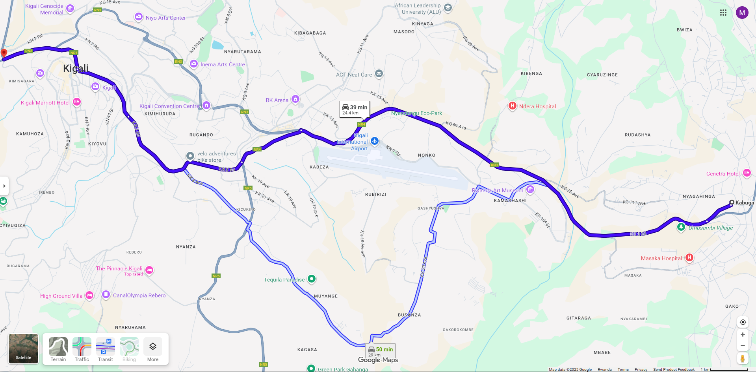
Figure 1: Kabuga - Nyabugogo Route (map-view)
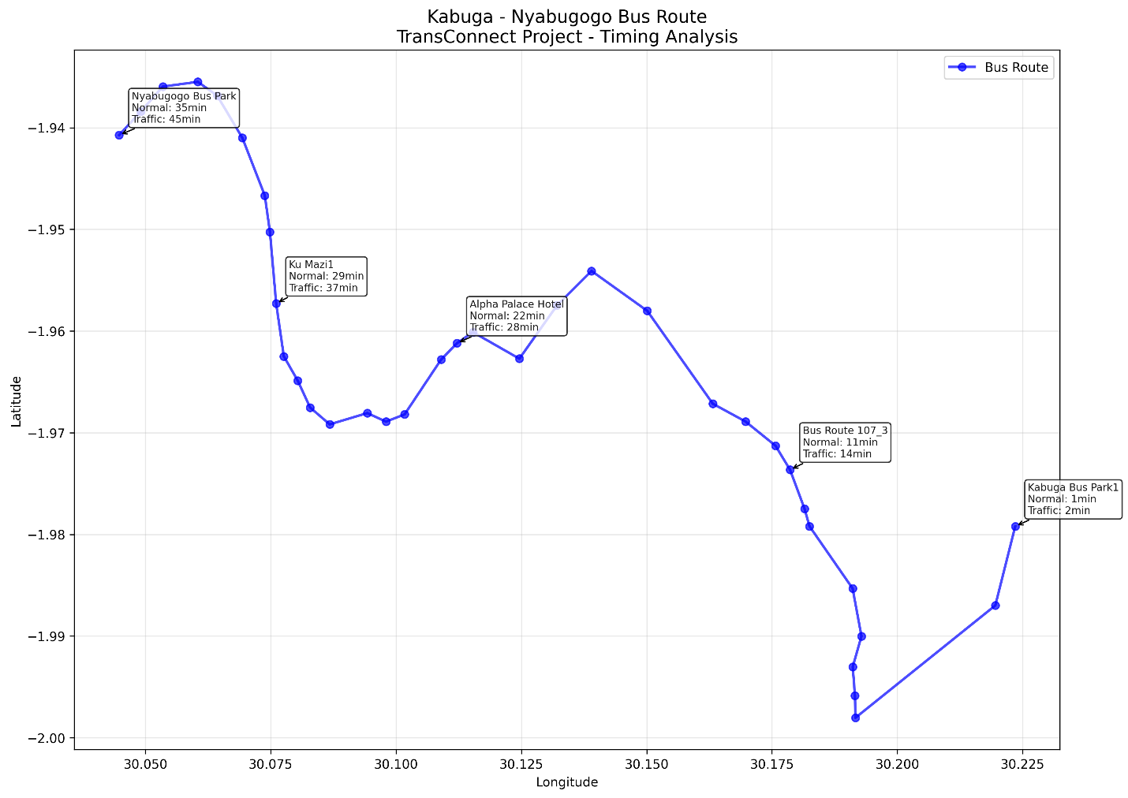
Figure 2: Kabuga - Nyabugogo Route (Preprocessed View)

3.2 Data Source and Description
The primary dataset was obtained from Kigali public transport records (former Kigali Bus Services), containing bus route details with the following attributes:
- Stops: Names of bus stops along the route
- Latitude and Longitude: Geographic coordinates in mixed formats (e.g., S1.97922, E30.22352)
- Route sequence: Order of stops from origin (Kabuga) to destination (Nyabugogo)
Initial Data Issues Identified:
- Mixed coordinate formats (with directional prefixes S and E)
- Potential missing values and duplicate entries
- Lack of standardized structure across routes

3.3 Data Preparation Pipeline
A systematic data preprocessing workflow was implemented to transform raw data into a model-ready format. The key steps are summarized below:
Step | Purpose | Actions Performed
1. Data Cleaning | Handle inconsistencies and missing values | Remove S/E prefixes from coordinates, convert to decimal degrees, drop rows with missing lat/lon or stop names, remove duplicates.
2. Data Integration | Unify data structure | Assign unique stop IDs, define route IDs, and create a route-stop sequence mapping for scalable multi-route management.
3. Data Reduction | Retain only relevant features | Remove irrelevant columns (e.g., Route Price), select core features: stop_id, latitude, longitude, stop_sequence.
4. Data Transformation | Engineer features for prediction | Apply Haversine formula to calculate distances between consecutive stops; estimate travel times assuming an average urban speed of 40 km/h.
5. Data Discretization | Convert continuous variables into categories | Segment cumulative distance into Start, Early, Mid, Late; categorize travel times into Very Short, Short, Medium, Long.
6. Data Augmentation | Enhance dataset robustness | Generate synthetic trips under varying conditions (rush hour, normal traffic); add temporal features (time_of_day, day_of_week).

3.4 Final Processed Dataset
After preprocessing:
- Original stops: 36
- Cleaned stops: 36
- Total route distance: 26.07 km
- Total estimated travel time: 62.6 minutes
- Augmented dataset size: 216 rows (including synthetic cases)
- Key features for modeling:distance_to_next, estimated_travel_time_min, route_segment, travel_time_category, condition (normal/rush hour), and temporal indicators.

3.5 Tools and Libraries
The preprocessing was implemented in Python using:
- Pandas and NumPy for data manipulation
- Scikit-learn for scaling and encoding
- Haversine library for geographical distance calculations
- Matplotlib/Plotly and Folium for visualization and mapping
This structured preparation ensured that the data was accurate, consistent, and enriched with meaningful features, forming a reliable foundation for training and evaluating AI models in subsequent phases.

